

|  |  |
| --- | --- |
| NAME: | BISWARUP  BHATTACHARJEE |
| ROLL: | 18 |
| SEC: | I |
| ASSIGNMENT NO: | 11 |

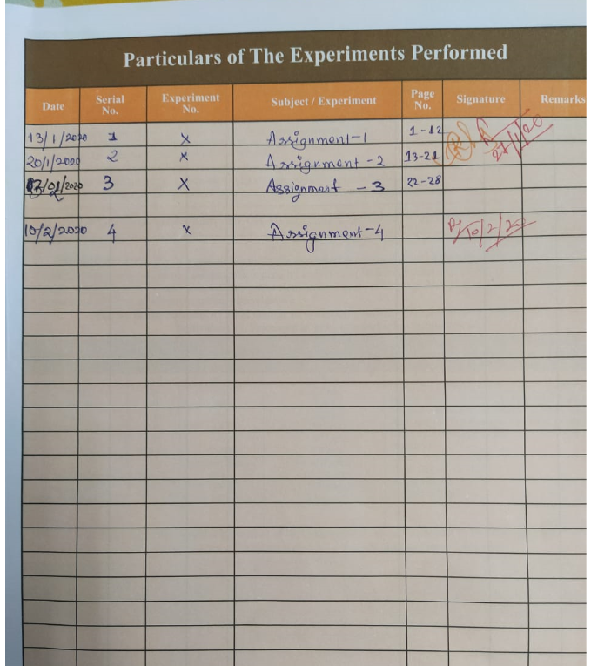

1. **Write a program in Python to print “Hello World!” using interactive interpreter prompt & using a script file.**

**Ans:**

print(**"hellow world"**)

***OUTPUT:***

hellow world

1. **Write a program in Python by assigning single value to multiple variables & by assigning multiple values to multiple variables.**

**Ans:**

a , b = 100 , 200*#multiple values are #assigning in multiple variables*c = d = 100 *#single value assigning in #multiple variable*print(a,c,d)

***OUTPUT:***

100 100 100

1. **Take 2 strings and write a program in Python to print first two character using slice operator, print 4th character of the string, print the string twice, and print the concatenation of the strings.**

**Ans:**

a=**"string1"***#TAKE 1ST STRING*b=**"string2"***#TAKE 2ND STRING*print(**"1ST 2-CHARACTERS OF STRING1 :: "**,a[0],a[1])  
print(**"\n2ND 2-CHARACTERS OF STRING1 :: "**,b[0],b[1])  
print(**"4TH CHARATER OF STRINGS :: "**,a[3],**","**,b[3])*#print 4th character*print(2*a,2*b)*#print twice*c=a+b*#string concatenation*print(c)

***OUTPUT:***

1ST 2-CHARACTERS OF STRING1 :: s t

2ND 2-CHARACTERS OF STRING1 :: s t

4TH CHARATER OF STRINGS :: i , i

string1string1 string2string2

string1string2

1. **Write a program in Python to print the 3rd item in a list & print the list thrice.**

**ANS:**

a=[1,2,3,4,5]  
print(a[2])*#Print 3rd item in the list*print(3*a)*#print thrice this list in one #list*

***OUTPUT:***

*3*

*[1,2,3,4,5, 1,2,3,4,5, 1,2,3,4,5,]*

**5.Write a program in Python to print a tuple.**

**Ans:**

tup=(1,2,3,4,5)  
print(tup)*#Print a tuple*

***OUTPUT:***

(1, 2, 3, 4, 5)

**6.Write a program in Python to print keys & values of a dictionary.**

**Ans:**

dic1={**"DOG"**:**"ANIMAL"**,**"KEY"**:**"VALUE"**}  
print(dic1.values())  
print(dic1.keys())

***OUTPUT:***

dict_values(['ANIMAL', 'VALUE'])

dict_keys(['DOG', 'KEY'])

7.Write a program in Python Program to check whether a number is even or not.

Ans:

num = int(input(**"Enter a number: "**))  
b=**"{0} is Even number"  
if** (num % 2) == 0:  
print(b.format(num))*#F-STRING IS USE FOR #PRINTING***else**:  
print(b.format(num))

***OUTPUT:***

Enter a number: 8

8 is Even number

### 8. Write a program in Python to print the table of the given number by using (a) for loop & (b) while loop.

### Ans:

num=int(input(**"Enter the number :: "**))  
**for** i **in** range(1,11):  
print(num,**"X"**,i,**"="**,num*i)  
i=1  
print(**"\n\n"**)  
**while**(i<11):  
print(num, **"X"**, i, **"="**, num * i)  
*i=i+1*

***OUTPUT:***

*Enter the number :: 3*

*3 X 1 = 3*

*3 X 2 = 6*

*3 X 3 = 9*

*3 X 4 = 12*

*3 X 5 = 15*

*3 X 6 = 18*

*3 X 7 = 21*

*3 X 8 = 24*

*3 X 9 = 27*

*3 X 10 = 30*

*3 X 1 = 3*

*3 X 2 = 6*

*3 X 3 = 9*

*3 X 4 = 12*

*3 X 5 = 15*

*3 X 6 = 18*

*3 X 7 = 21*

*3 X 8 = 24*

*3 X 9 = 27*

*3 X 10 = 30*

### 9. Write a program in Python to calculate the sum of two variables by using function.

### ANS:

**def** addition(a,b):  
 **return** a+b  
a=5  
b=6  
print(addition(a,b))*#using function add two #numbers*

***OUTPUT:***

11

### 10.Write a program in Python to calculate the sum of two variables by using built-in function.

### ANS:

a=[10,20]  
print(sum(a))*#sum using built in funtion*

***OUTPUT:***

### 30